Would you like to be involved in the Friends Group?
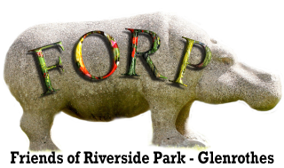
Website: www.forpglenrothes.org.uk
Email: forpglenrothes@hotmail.co.uk
Find us on Facebook
(The one with the Hippo logo)

Please complete the following if you would like to be involved in the Friends of Riverside Park Group?

Name: ………………………………………………………………………………...………….…

Phone: ………………………………………….…... Post code: …………………….…

Email: ………………………………………………….……………………………………………
Your Location. Are you, (please tick ) Local? * Several miles away?* More distant?*

Here is a list of future projects you may be interested in helping with.
Please tick any you are particularly interested in helping with.

* Litter picks. Bug Hunts, Easter egg trail, Reindeer trail, Picnic in the park.

* Harvest festival event, pruning in the orchard, maintaining the two small FORP garden areas.

* Producing written material for information and interpretation boards distributed throughout the park

* Identifying places to install new barbecue stations

We are also looking for help to run our organisation at these various levels.
Please tick any or all you would like to be involved with.

* Park Volunteers - to participate in or help during events and projects.

* Park Champions – to help organise events and projects

* FORP committee members – to plan and oversee the organisation of events and projects.

If you have your own talents to offer, please comment below.

……………………………………………………………………………………………………………

Data Protection:
This information will be stored on computer for the purpose of administration and will not be passed to any third party.

